**Mobile Application Development (7421ICT)**

Trimester 1, 2024

Assignment 2

**Fake Store**

Final Submission

Student Name: Tom Sabu

Student ID: s5372877

Student Email: tom.sabu@griffithuni.edu.au

Course Code: 7421ICT

Table of Contents

Project Overview 3

GitHub URL Link 3

GitHub Commit History 3

Video Link 3

1. Splash Screen 4

2. Product Category List Screen 4

3. Product List Screen 5

4. Product Detail Screen 5

5. Shopping Cart Screen 6

6. User Profile Screen 6

7. Sign In Screen 7

8. Sign Up Screen 7

Project Reflection 7

## Project Overview

The project aimed to develop a mobile application for a fictional online store, named "FakeStore," using React Native. The application provides various functionalities, including browsing product categories, viewing product details, adding products to the shopping cart, managing orders, user authentication, and updating user profiles.

## GitHub URL Link

GitHub URL: <https://github.com/tomcruzz/Assignment2-s5372877-7421ICT.git>

The project's source code is hosted on GitHub in the above repository. The repository contains the entire codebase, including components, screens, navigation, and Redux store configurations.

## GitHub Commit History

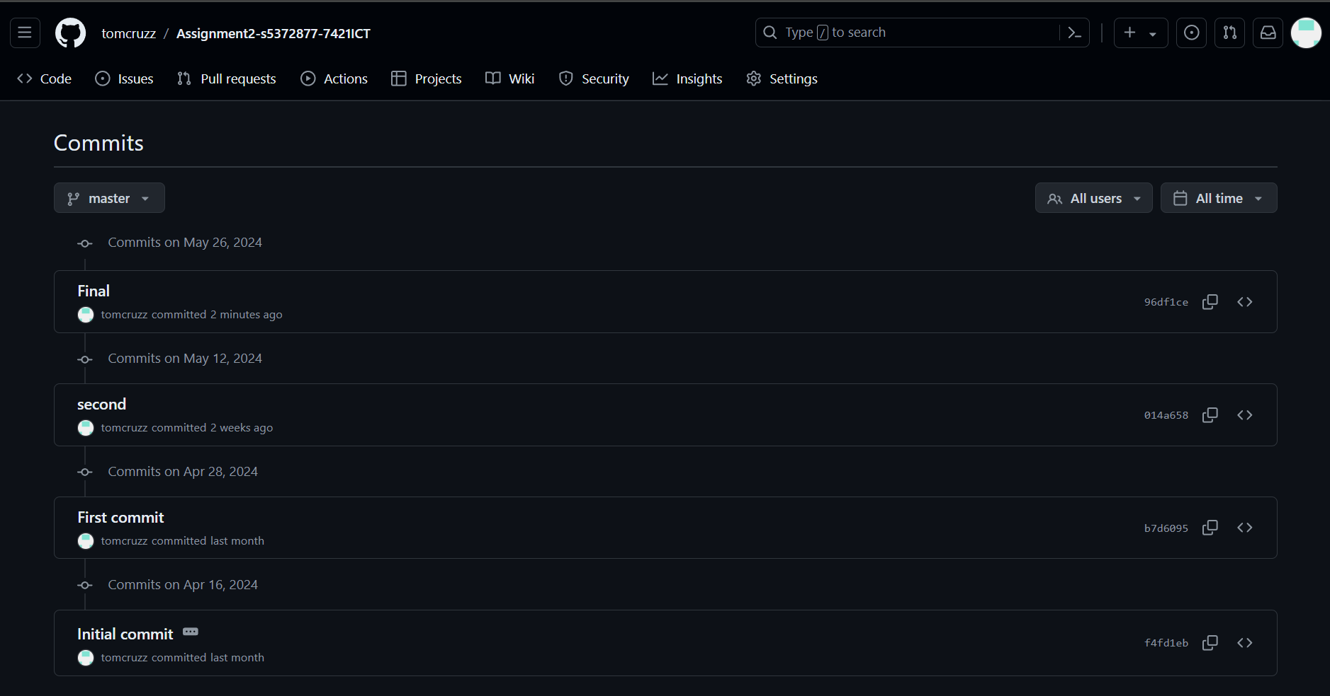

## Video Link

Youtube Video Link: <https://youtu.be/7HpKvglouk8>

A video demonstration showcasing the application's features and functionalities. The video provides a walkthrough of the app, demonstrating how users can navigate through different screens, browse products, add items to the shopping cart, manage orders, and interact with the user profile.

## 1. Splash Screen

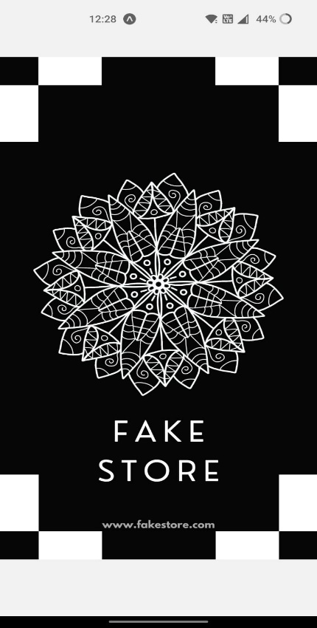

## 2. Product Category List Screen

## 3. Product List Screen

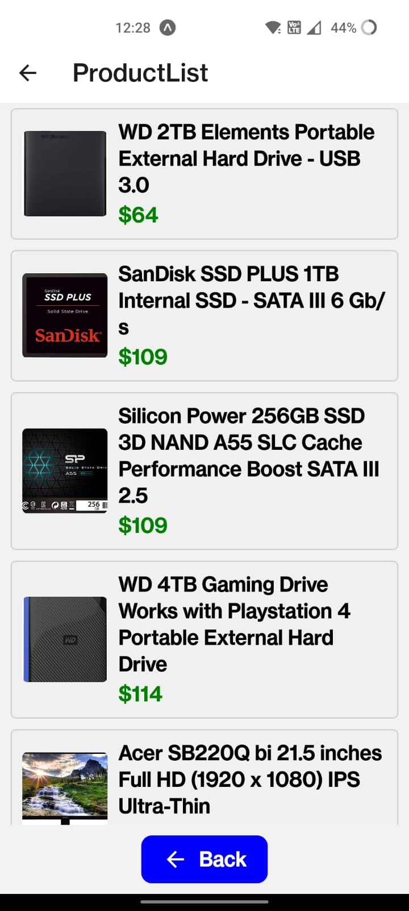

## 4. Product Detail Screen

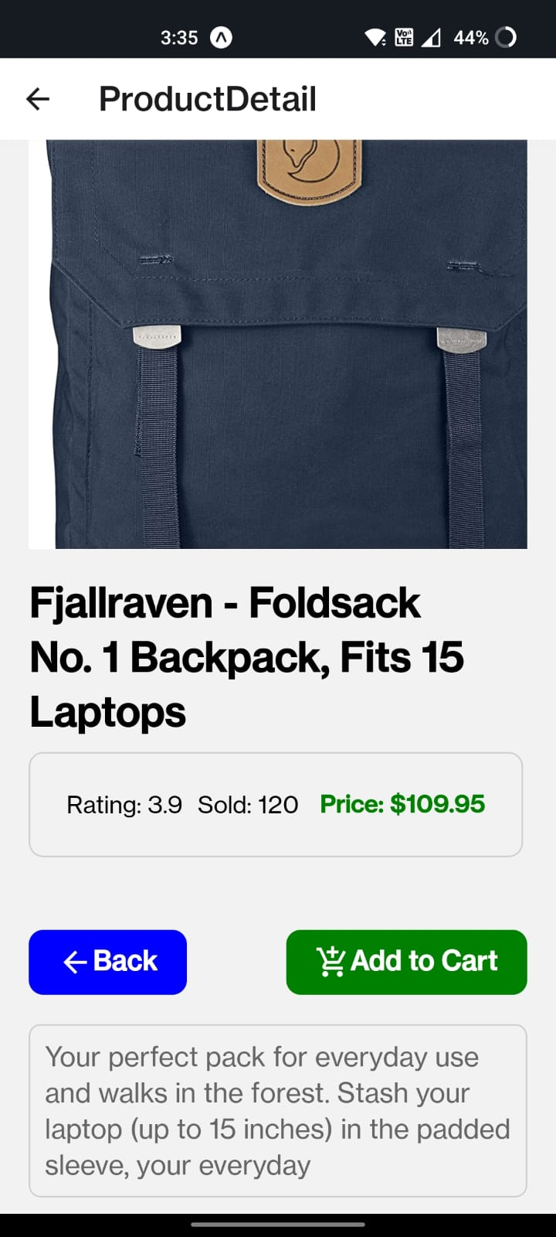

## 5. Shopping Cart Screen

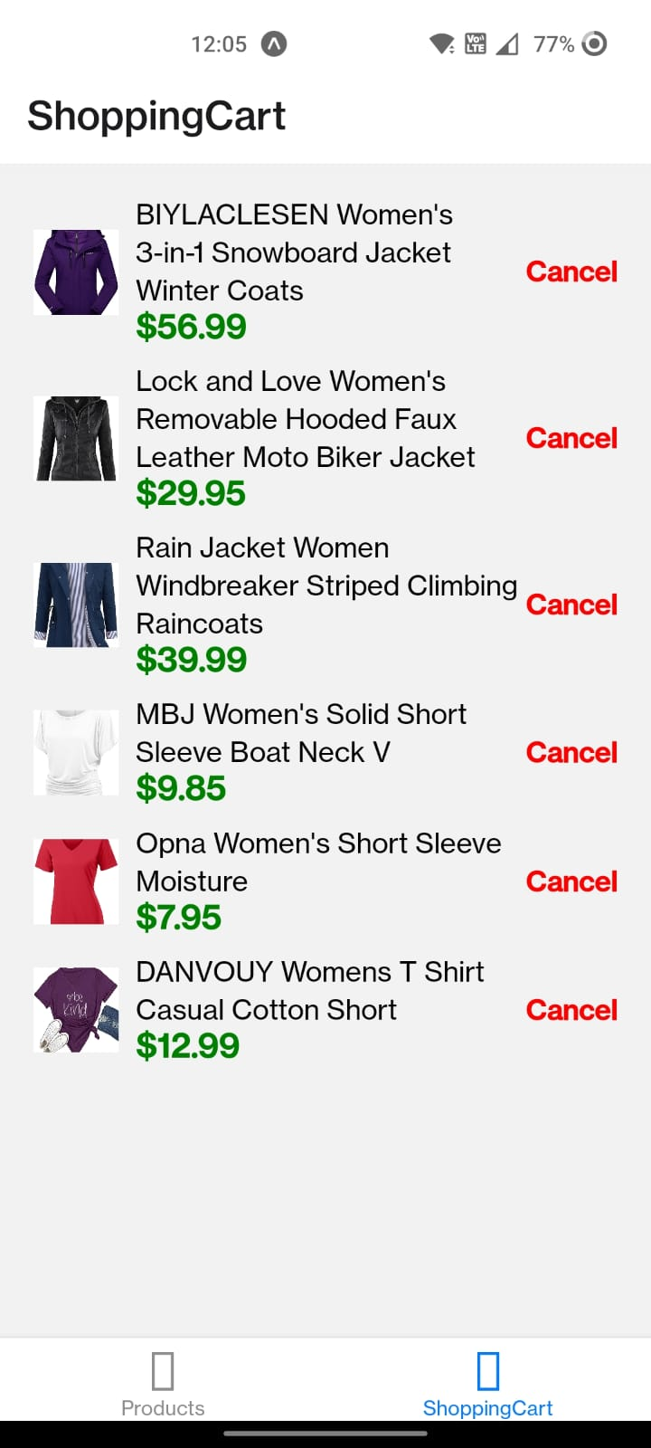

## 6. User Profile Screen

## 7. Sign In Screen

## 8. Sign Up Screen

## Project Reflection

The development process involved several key stages, including:

* Planning and Design: The project started with planning and designing the app's architecture, user interface, and functionality. Wireframes and mockups were created to visualize the application's layout and user flow.
* Development: Development began with setting up the project structure, including creating components, defining navigation, integrating Redux for state management, and implementing API calls for fetching data and handling user authentication.
* Testing and Debugging: Throughout the development process, rigorous testing and debugging were conducted to ensure the app's stability, functionality, and performance. Unit tests, integration tests, and manual testing were performed to identify and fix bugs and issues.
* Optimization: Optimization efforts focused on improving the app's performance, reducing load times, and enhancing user experience. Techniques such as code splitting, lazy loading, image optimization, and data caching were employed to achieve optimal performance.
* Deployment: Once development and testing were complete, the application was deployed to the desired platforms, including iOS and Android devices. Continuous integration and continuous deployment (CI/CD) pipelines were set up to automate the deployment process and streamline updates.

Overall, the project was a valuable learning experience, providing insights into mobile app development, React Native, Redux state management, API integration, and user authentication. It demonstrated the importance of thorough planning, effective collaboration, and continuous testing and optimization in delivering a high-quality mobile application.